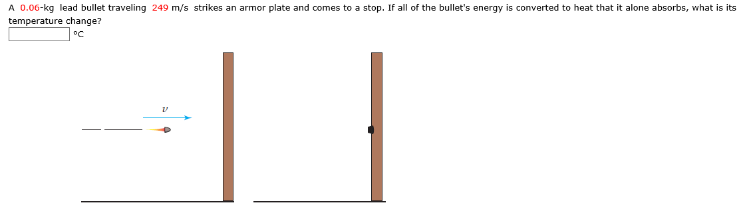
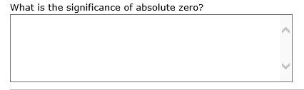
What happens to the atoms and molecules in a substance as its temperature increases?
